 | SANDIP FOUNDATION'S  SANDIP POLYTECHNIC,NASHIK | 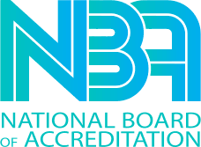
Date:-12th Aug 2025

Name of Event:-The Celebration of Library Day Date of Event: - 12th Aug 2025
Venue:-Sandip Polytechnic, Nashik. Objectives:-
- To promote reading habits
Encourage people, especially students, to read books and use libraries regularly.
- To create awareness about libraries
Make people understand the importance of libraries in education and lifelong learning.
- To honor Dr. S. R. Ranganathan
Library Day (12 August) is celebrated to remember Dr. S. R. Ranganathan, the father of library science in India.
- To support education and knowledge sharing
Highlight the role of libraries in spreading knowledge to everyone.
- To encourage proper use of library resources
Teach people how to use books, journals, and digital resources effectively.

Outcomes:-

- Increased interest in reading
More people develop a habit of reading books and newspapers.
- Better use of libraries
Students and the public start visiting libraries more often.
- Awareness about library services
People learn about different services like digital libraries, e-books, and reference sections.
- Motivation among students
Students feel inspired to study, research, and gain knowledge.

.

Photo Gallery

